Name:__________________ Date:_______________
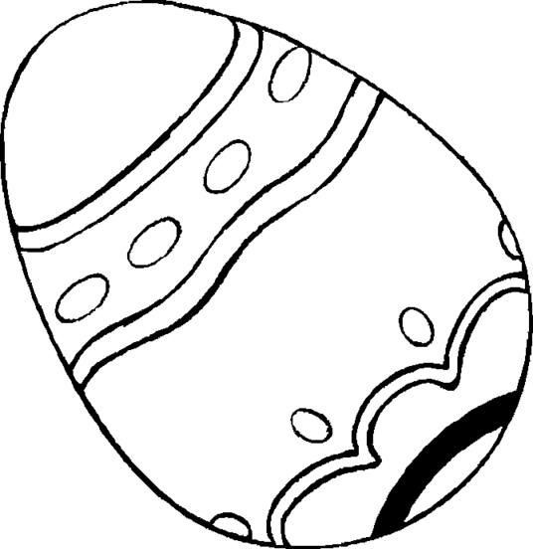
Easter Goodies

Colour in the pictures. Label each picture. Fill in the missing words.
Choose the appropriate words from the boxes below.
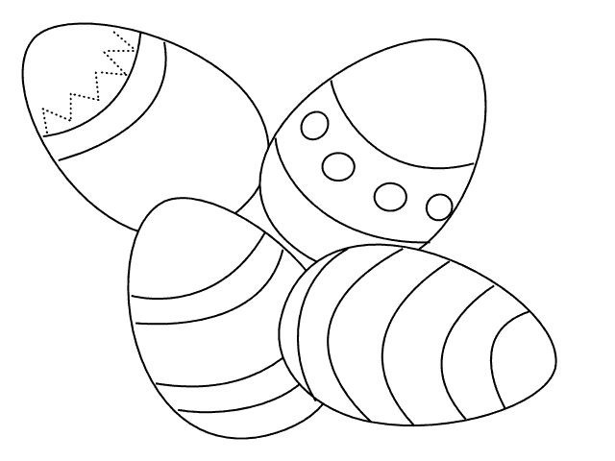  ____________________ | Some Easter eggs are ____________.  Giving Easter eggs symbolise _______ ________.  life  decorated  new
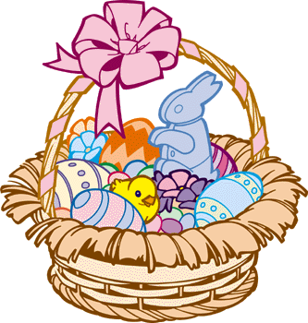  ____________________  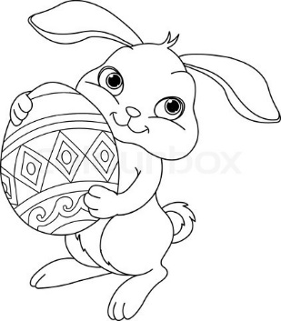 | The Easter bunny hides the _______ in the house or garden. The children  find the eggs on ________ _______.  Easter  eggs  morning
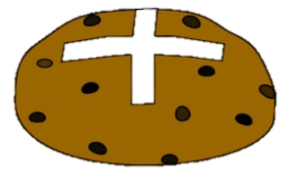  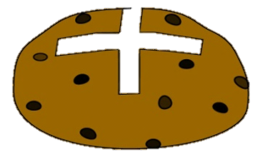  _____________________ | Hot cross buns are eaten on  _________________. The cross in the middle reminds __________ that Jesus died on the ___________.  Good Friday  cross  Christians

