Name:________________________ Date:_______________

Special Days in Holy Week

Write a sentence about what happened in each picture.

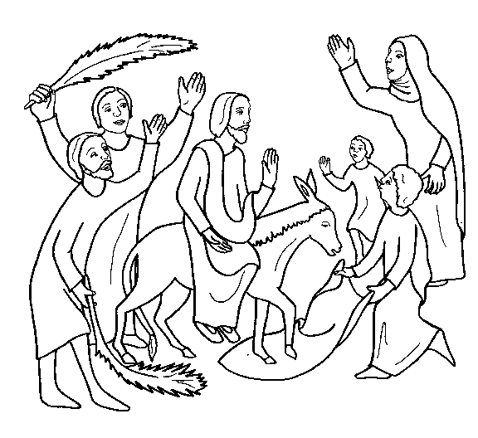 | Palm Sunday  ________________________  ________________________  ________________________  ________________________

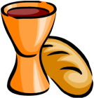  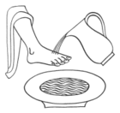  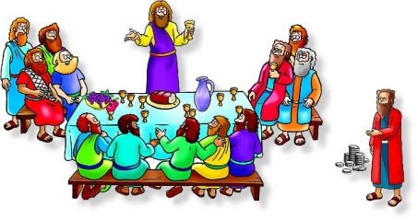 | Maundy Thursday (Last Supper)  ________________________  ________________________  ________________________  ________________________

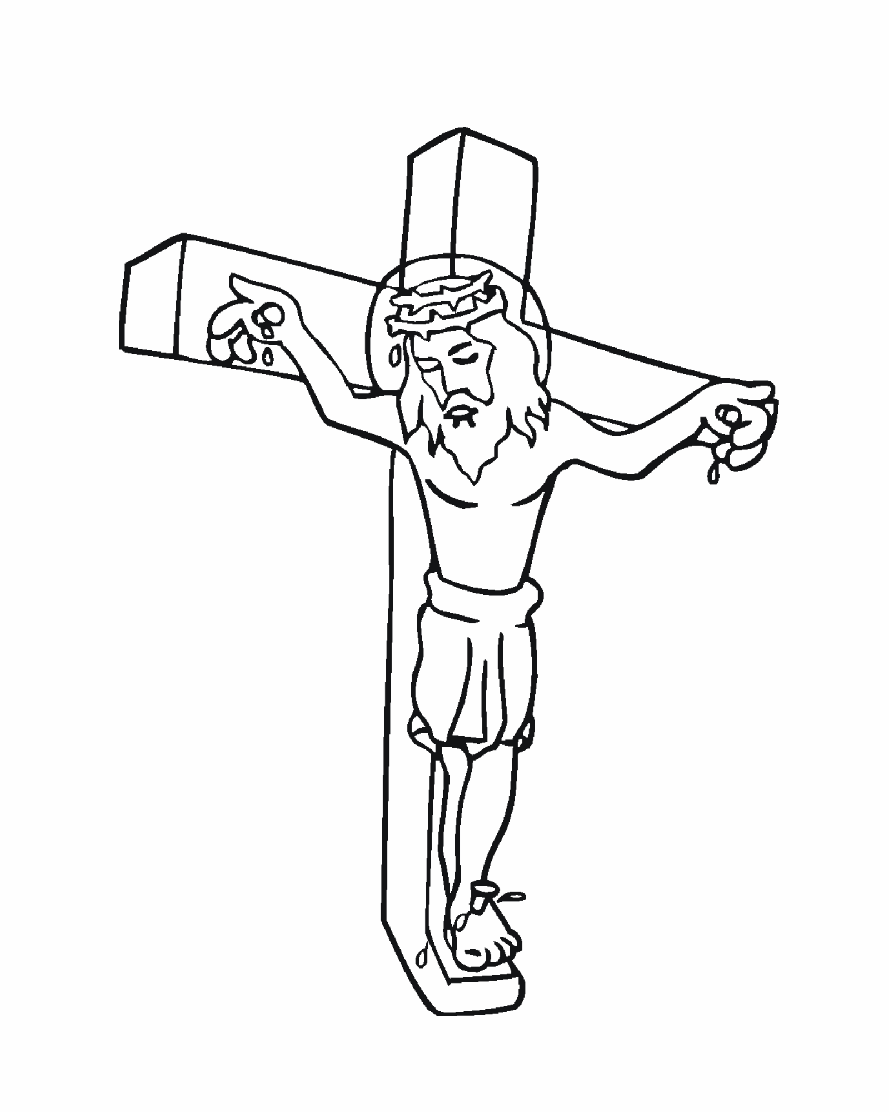 | Good Friday  ________________________  ________________________  ________________________  ________________________

