Name: ________________________ Date: _______________

The Easter Story

Write about what happened in the Easter story.
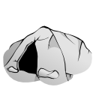
Use the pictures to help you.




